CREATE TABLE Item(

Item_id INT PRIMARY KEY,

Item_name VARCHAR(15)

);

CREATE TABLE Shop(

Shop_id INT PRIMARY KEY,

Shop_name VARCHAR(25)

);

CREATE TABLE Unit_details(

Unit_id INT PRIMARY KEY,

Unit VARCHAR(20),

Count INT

)

CREATE TABLE Sales_order_details(

Item_id INT,

shop_id INT,

Quantity INT,

Unit_id INT,

Unit_price INT,

sale_date DATE,

CONSTRAINT fk_item FOREIGN KEY(Item_id) REFERENCES Item(Item_id),

CONSTRAINT fk_shop FOREIGN KEY(shop_id) REFERENCES Shop(shop_id),

CONSTRAINT fk_unit FOREIGN KEY(Unit_id) REFERENCES Unit_details(unit_id)

);

INSERT INTO Item(Item_id,Item_name)

VALUES (1,'Bar-One'),(2,'KitKat'),(3,'MilkyBar'),

(4,'Munch')

INSERT INTO Shop(Shop_id,Shop_name)

VALUES (1,'Amal Stores'),(2,'Jyothi Stores'),(3,'Indira Stores')

INSERT INTO Unit_details

VALUES(1,'Piece',1),

(2,'Box Pack',28)

INSERT INTO Sales_order_details(Item_id,shop_id,Quantity,Unit_id,Unit_price,sale_date)

VALUES (1,1,100,1,10,'2018-10-05'),

(2,1,200,1,15,'2018-10-05'),

(3,1,50,1,5,'2018-10-05'),

(4,1,150,1,10,'2018-10-05'),

(1,2,10,2,280,'2018-10-10'),

(2,2,30,2,420,'2018-10-10'),

(3,2,40,2,140,'2018-10-10'),

(4,2,20,2,280,'2018-10-10'),

(1,3,50,2,280,'2018-09-15'),

(2,3,70,2,420,'2018-09-15'),

(3,3,30,2,140,'2018-10-10'),

(1,1,150,1,10,'2018-09-15'),

(2,1,250,1,15,'2018-09-15'),

(4,1,200,1,10,'2018-10-10')

--Q1.2

SELECT TOP 1 Item_name,SUM(Quantity*Unit_price) AS revenue FROM Item i

INNER JOIN Sales_order_details s

ON i.Item_id = s.Item_id

WHERE MONTH(sale_date) =10

GROUP BY i.Item_name

ORDER BY revenue DESC

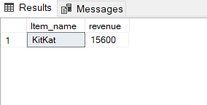

--Q1.3

SELECT TOP 1 I.Item_name,SUM(SO.Quantity) AS TotalQuantitySold

FROM

Item AS I

INNER JOIN Sales_order_details AS SO ON I.Item_id = SO.Item_id

INNER JOIN Shop AS S ON SO.shop_id = S.Shop_id

WHERE

DATEPART(MONTH,SO.sale_date) =10

AND SO.shop_id= 1

GROUP BY

I.Item_name

ORDER BY

TotalQuantitySold DESC

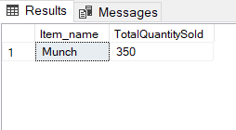

--Q1.4

SELECT

I.Item_name,

SUM(S.Unit_price * S.Quantity) AS TotalRevenue

FROM

Sales_order_details S

INNER JOIN ITEM I ON S.Item_id = I.Item_id

WHERE

DATEPART(MONTH,S.sale_date) = 10

GROUP BY

I.Item_name

HAVING

SUM(S.Unit_price * S.Quantity) > 10000

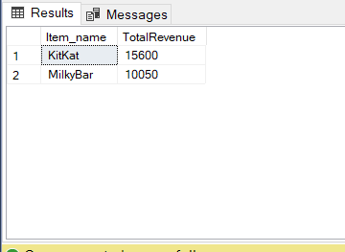

--Q1.5

SELECT TOP 1

SP.Shop_name,

SUM(S.Unit_price * S.Quantity) AS TotalRevenue

FROM

Sales_order_details S

INNER JOIN SHOP SP ON S.Shop_id = SP.Shop_id

WHERE

DATEPART(MONTH,S.sale_date) = 10

GROUP BY

SP.Shop_name

ORDER BY

TotalRevenue DESC

